**Step1:** Create the Sample Web App in IIS with Port 80

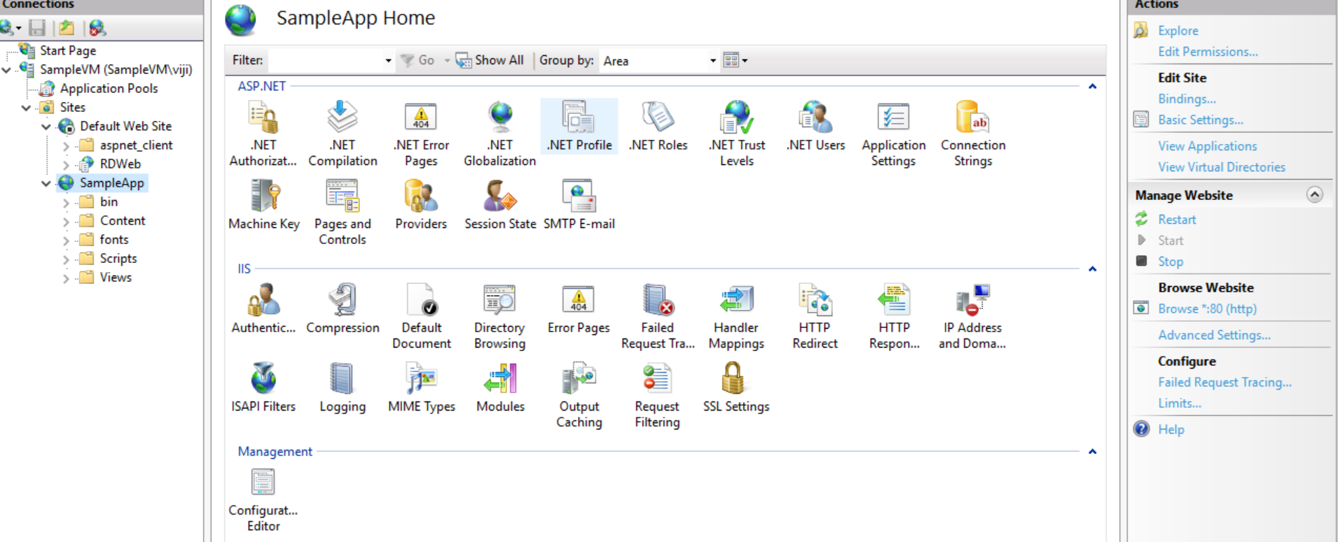

**Step2:** Check the Site Access in the following URL:

<https://migrate4.azurewebsites.net/>

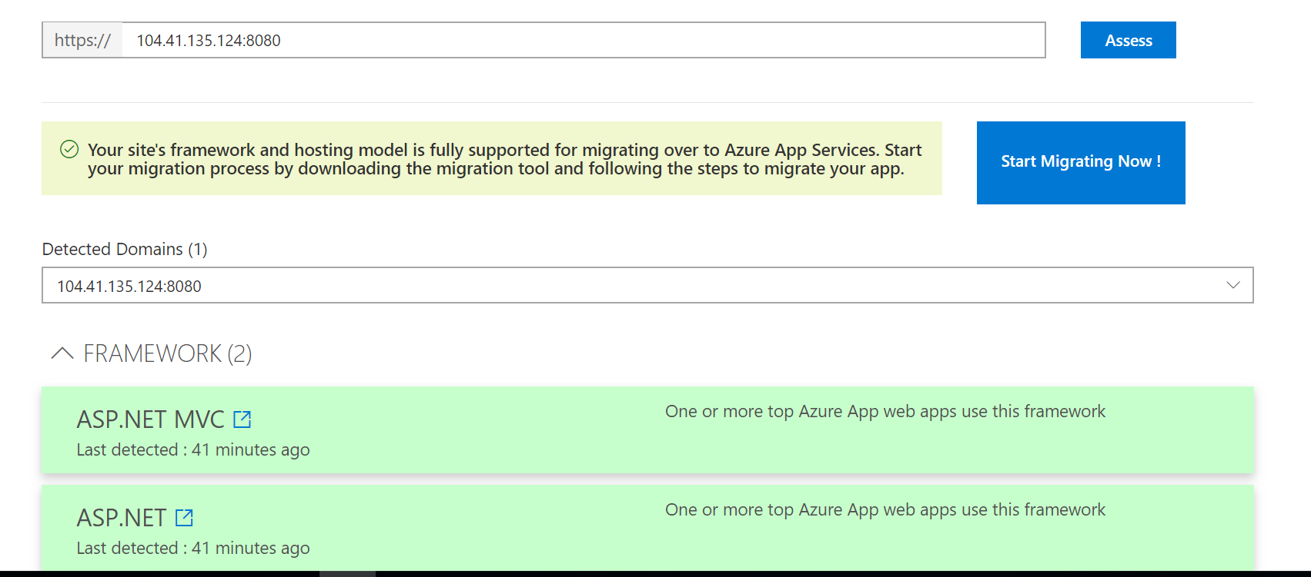

**Step3:** Get the Azure App Service Migration Assistant in the following Link:

<https://migrate4.azurewebsites.net/readiness>

**Step4:** Open the Migration App and Select Continue with Migrate sites and databases on local server to Azure

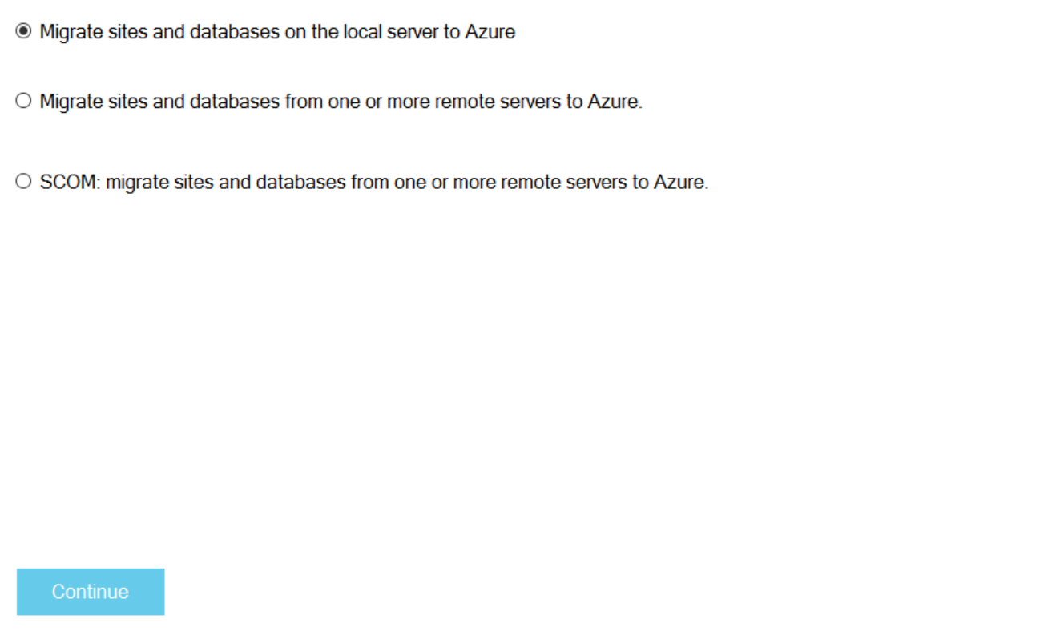

**Step5:** Select your web site and click next

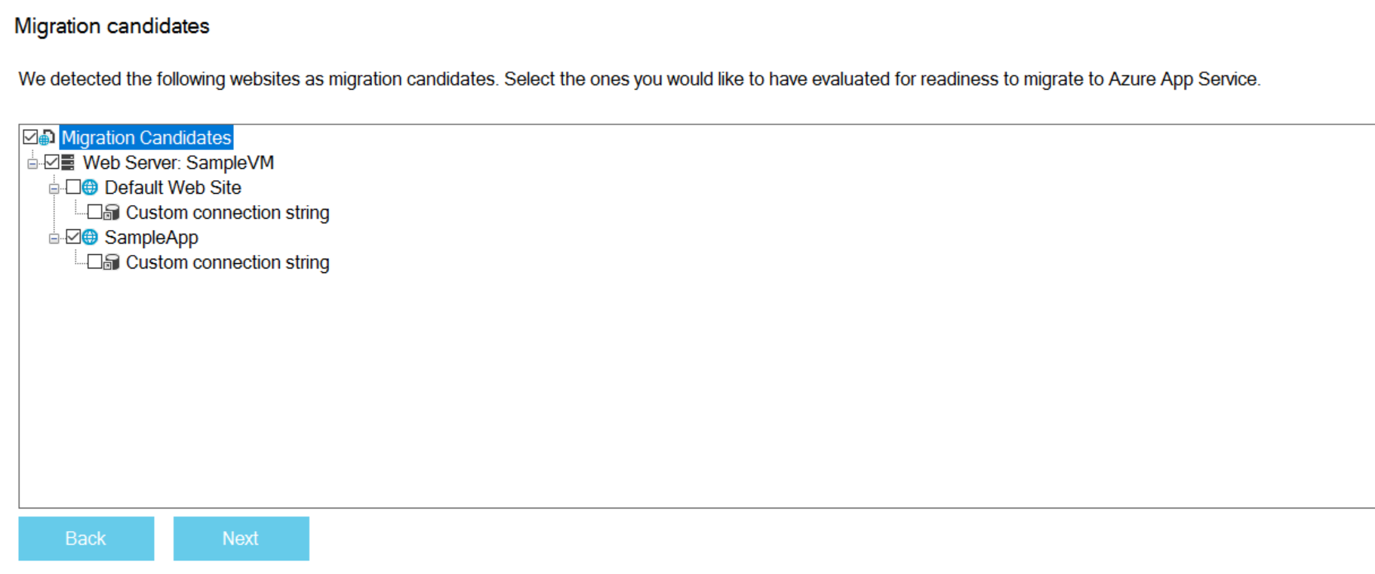

**Step6:** Select the Readiness Assessment

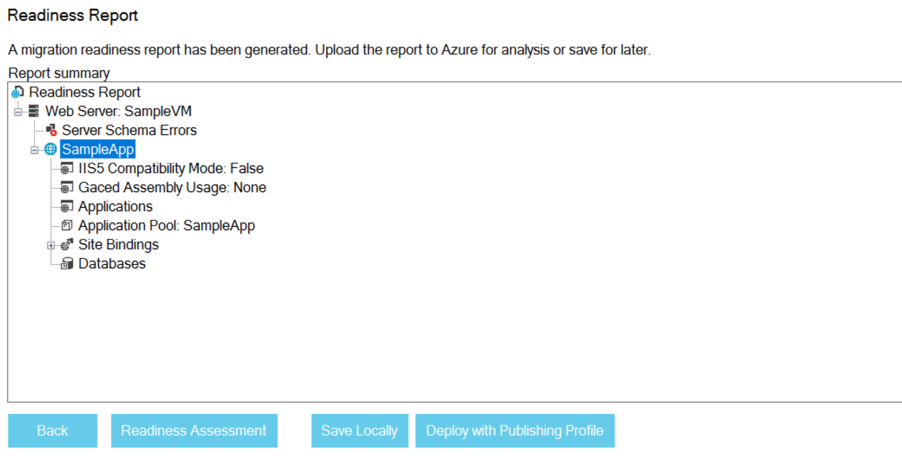

**Step7:** Click Begin Migration

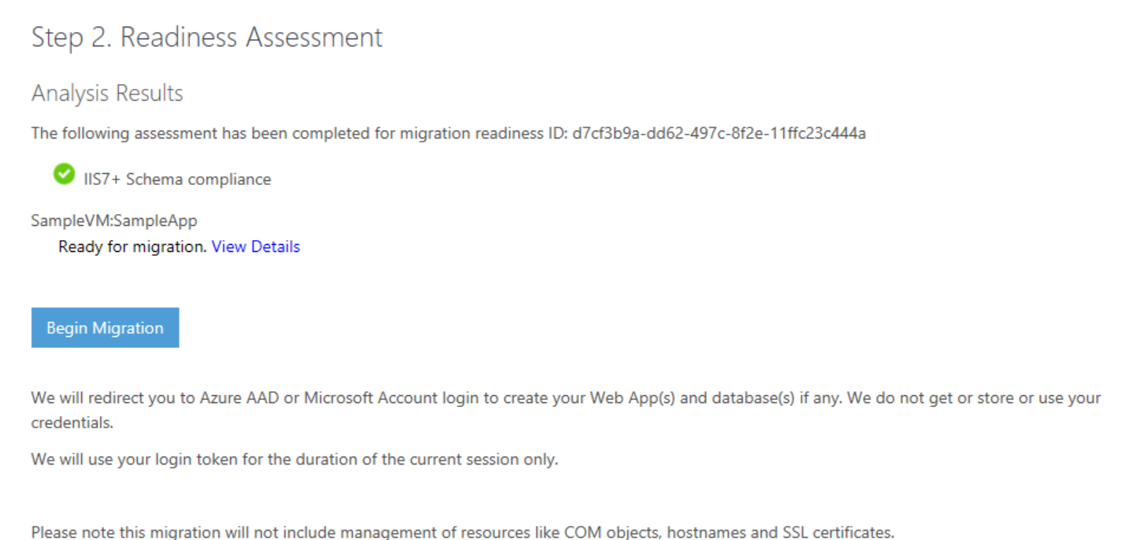

**Step8:** Add the Subscription, Resource group and Location

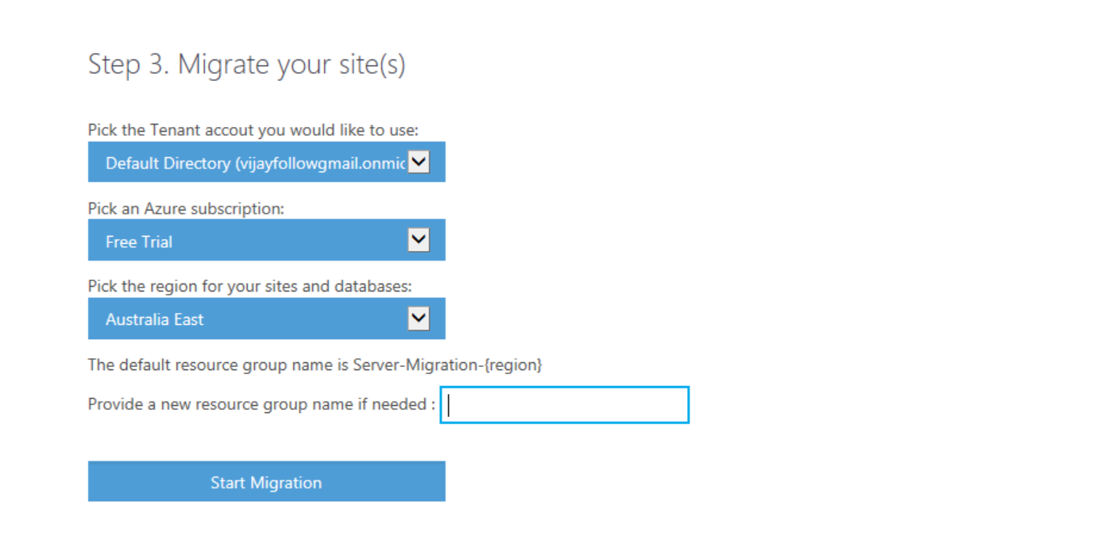

**Step9:** Select IIS Web Site and configure the Azure App and click create

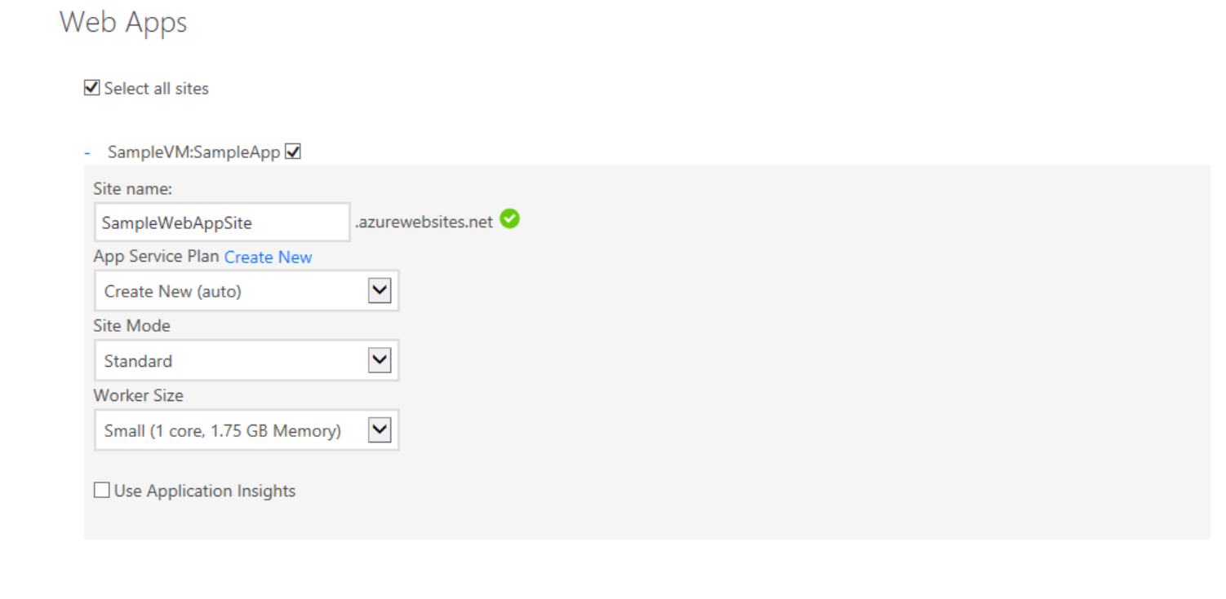

**Step10:** Click Begin Publish

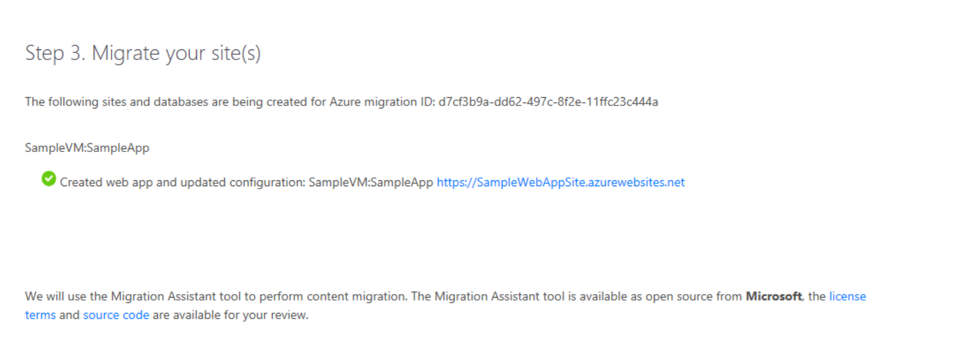

**Step11:** App Service Migration Assistant Successfully deployed into Azure Web App:

